**SPH3U: 2.3 Projectile Motion**

1. **Projectile motion**

|  |  |
| --- | --- |
| Projectile: |  |
| projectile motion |  |
| projectile motion vs. river crossing |  |
| range |  |
| convention |  |

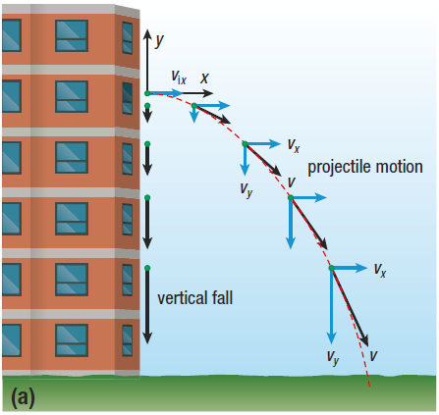 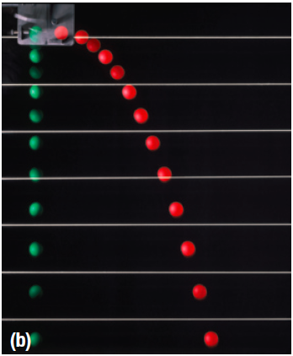

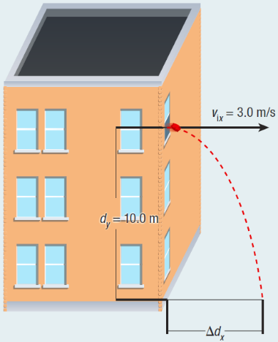A beanbag is thrown from a window 10.0 m above the ground with an initial horizontal velocity of 3.0 m/s.

1. How long will it take the beanbag to reach the ground (what is its time of flight)?
2. How far will the beanbag travel horizontally (what is its range)?
3. 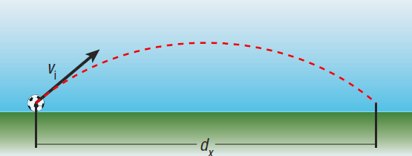**Launching a projectile at an angle**

A soccer player running on a level playing field kicks a soccer ball with a velocity of 9.4 m/s at an angle of 40° above the horizontal. Determine the soccer ball’s:

1. time of flight
2. range
3. maximum height

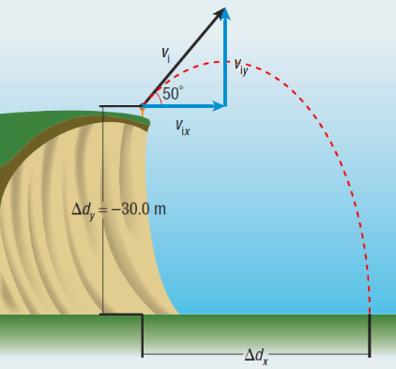A golfer is trying to improve the range of her shot. To do so she drives a golf ball from the top of a steep cliff, 30.0 m above the ground where the ball will land. If the ball has an initial velocity of 25 m/s and is launched at an angle of 50° above the horizontal, determine the ball’s:

1. time of flight
2. range
3. final velocity (just before it hits the ground)

**Homework:** page 81: #1-2, 4, 6